Streamlit dashboard link
https://project-9-frq3nh5nskwhdeieqxg9sa.streamlit.app/

1st input in streamlit dashboard - Global crude oil prices market trends
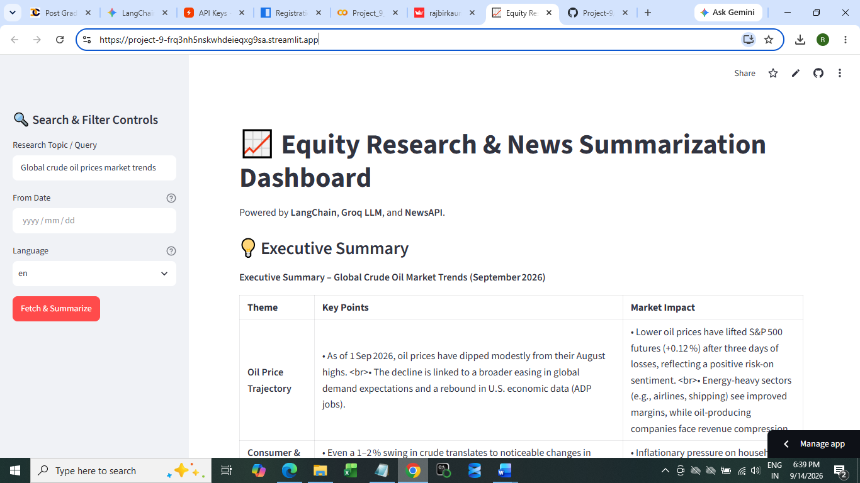

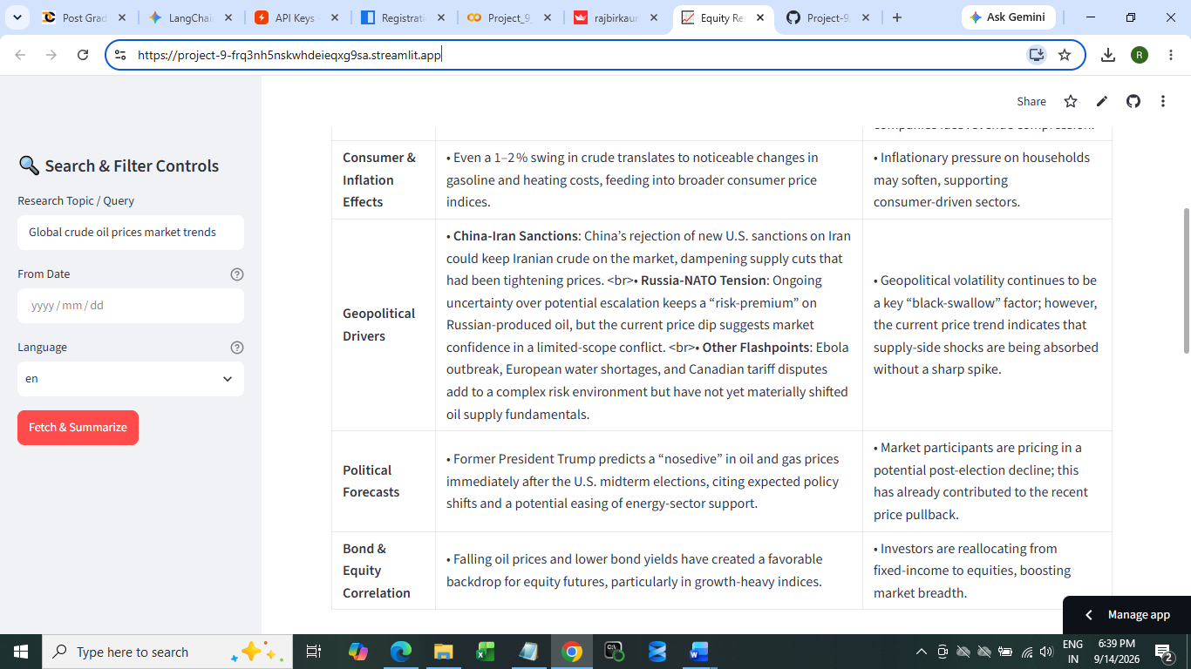

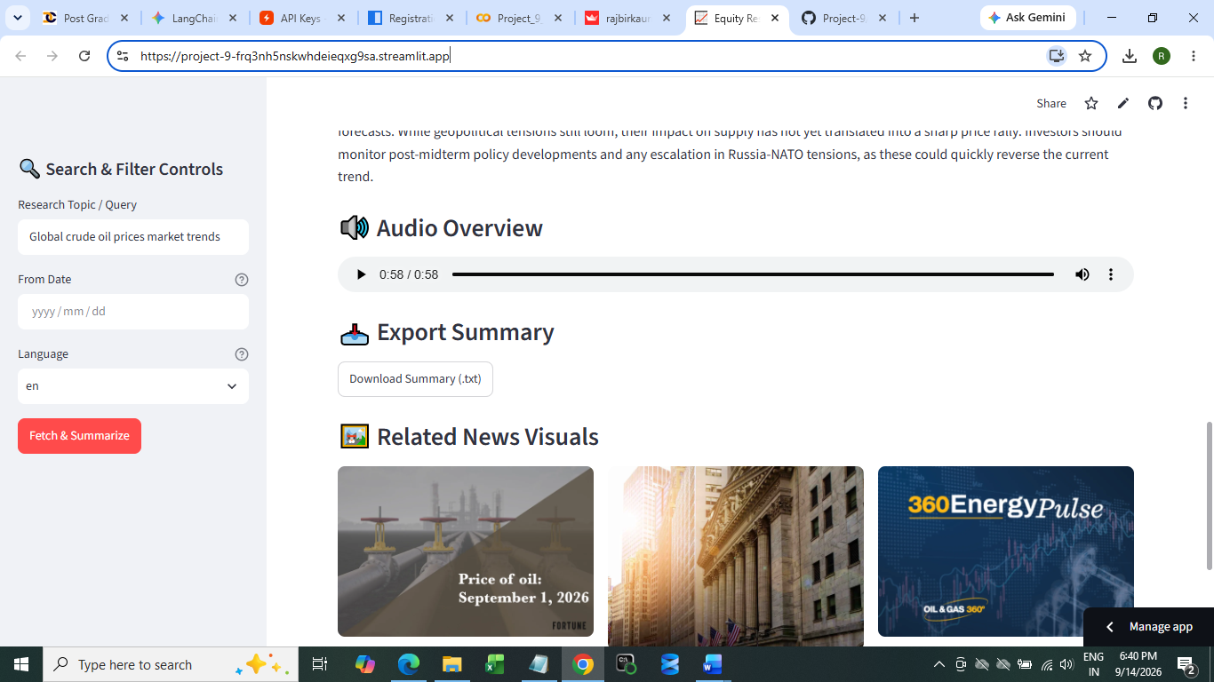

2nd input –
Artificial Intelligence impact on tech stocks

